# IMDB MOVIE ANALYSIS

#### About This Project

The objective of this project is to analyse and investigate the factors that influence the success of the movie on imdb. We are gathering data from various aspects of a movie and we are trying to find the correlation between them and the movie’s success. The five aspect we are working on are language, budget, genre, director and duration of the movie.

#### Approach

We are following a systematic Approach to get our desired result. So,

1. We are going to do the data cleaning to remove the blanks, duplicates and irrelevant data,
2. We are going to do the analysis on the data to extract information from it. For that we are using Excel.
3. Then we are going to take insights from our analysis to create a report and conclude our project.

#### Tech Stack

For this project we are using excel to analyse data and to create visual representation for it. We will also use notepad and Wps office for report writing.

#### Insight

1. **Movie Genre Analysis**

Here are analyzing the Genres of each movie to find out the most common genre and its relation to IMDB score. In our analysis we got the insight that Action, Comedy, Drama, Adventure and Crime are the most common genre.

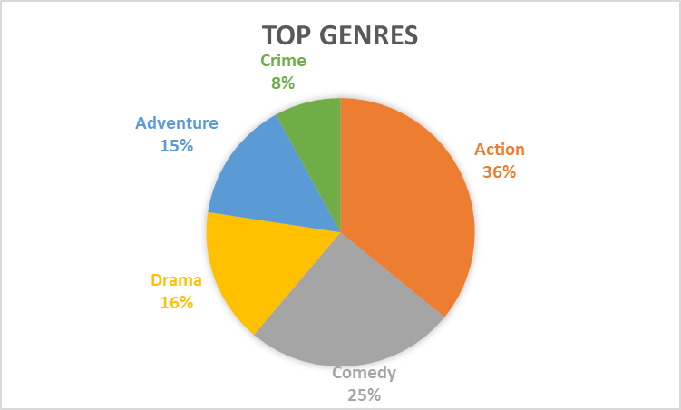

|  |  |
| --- | --- |
| Top 5 Genres |  |
| Action | 3606 |
| Comedy | 2538 |
| Drama | 1630 |
| Adventure | 1468 |
| Crime | 802 |

Descriptive statistics on genre-

|  |  |
| --- | --- |
| Average | 640.6666667 |
| Median | 85 |
| Mode | 4 |
| Max | 3606 |
| Min | 0 |
| Variance | 1067878 |
| Std. Dev. | 1033.381827 |

1. **Movie duration**

From this analysis we get the insight that a movie ranging between 120 to 150 minutes is most common on IMDB. However there is low correlation between a movie’s success and its duration but we found that a movie having more than 200 minutes of duration have IMDB score of 6 and higher up to 8.5.

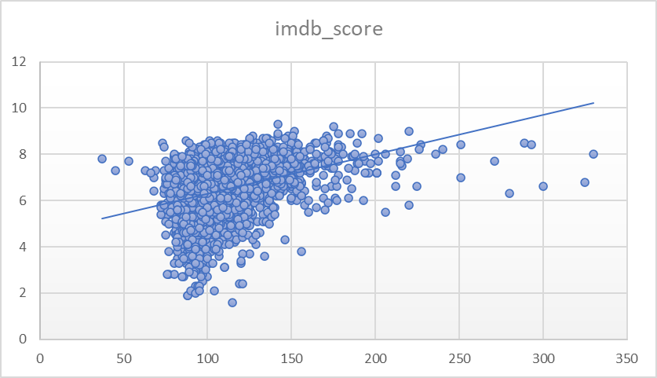

#### Language Analysis

Here we compared the languages of all the movies and their score on IMDB to check if there is any relation between language of movie and their success. We found that the most common movie language is English followed by French, Spanish, Mandarin and Japanese respectively. And the Highest rated movies are of Persian, Hebrew, Danish, Indonesian and Romanian languages respectively.

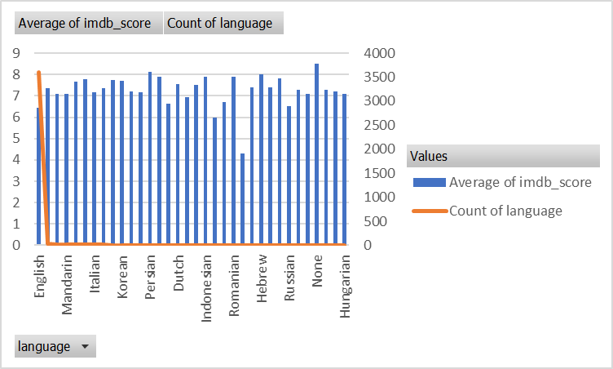

#### Director Analysis

Here we analyzed the performance of directors by calculating the average IMDB scores of their movies. Directors which directed most movies have on average higher IMDB scores.

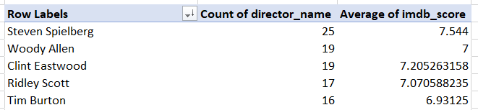

|  |  |  |
| --- | --- | --- |
|  |  |  |
| **Row Labels** | **Count of director_name** | **Average of imdb_score** |
| Akira Kurosawa | 1 | 8.7 |
| Tony Kaye | 1 | 8.6 |
| Charles Chaplin | 1 | 8.6 |
| Alfred Hitchcock | 1 | 8.5 |
| Ron Fricke | 1 | 8.5 |
| Majid Majidi | 1 | 8.5 |
| Damien Chazelle | 1 | 8.5 |
| Sergio Leone | 3 | 8.433333333 |
| Christopher Nolan | 8 | 8.425 |
| Richard Marquand | 1 | 8.4 |
| Asghar Farhadi | 1 | 8.4 |
| **Grand Total** | **20** | **8.47** |

These ten directors have the most high rated movies on IMDB.

#### Budget Analysis

Here we are analyzing the correlation between movie budget and their gross earnings. Which is -0.952569868. It shows that there is strong negative correlation between a movie’s budget and its profit. That means the higher the budget the less likely is is to be profitable and vice versa.

|  |  |
| --- | --- |
| **Row Labels** | **Max of profit** |
| AvatarÂ | 523505847 |
| E.T. the Extra-TerrestrialÂ | 424449459 |
| Jurassic WorldÂ | 502177271 |
| Star Wars: Episode I - The Phantom MenaceÂ | 359544677 |
| Star Wars: Episode IV - A New HopeÂ | 449935665 |
| The AvengersÂ | 403279547 |
| The Dark KnightÂ | 348316061 |
| The Hunger GamesÂ | 329999255 |
| The Lion KingÂ | 377783777 |
| TitanicÂ | 458672302 |
| **Grand Total** | **523505847** |
|  |  |

These are the top 10 most profitable movies and Avatar is the Top Most Profitable movie.

# Thank You